6. ENTROPY
ENTROPY IN CLOSED SYSTEM:
Entropy is a property (Extensive Property). | $$\oint{dS}≤0, Where dS=\frac{Q}{T}=Change in Entropy$$ | $$\oint{dS}=\oint{{\left[\frac{Q}{T}\right]}_{Rev}}=0$$
PHYSICAL MEANING OF ENTROPY: It’s measure of disorderness of the molecules. Greater the disorderness grater is entropy. And lesser is efficiency.
TEMPERATURE ENTROPY DIAGRAM:
Area under process Curve on T-S diagram represents heat transfer for reversible process. | $$Q_{Rev}=TdS$$

P-V DIAGRAM | T-S DIAGRAM
Area bounded between reversible process curve and Volume axis represents Work transfer for closed system. | Area bounded between reversible process curve and Entropy axis represents Heat transfer for closed system.
$$W_{Rev}=PdV$$ | $$Q_{Rev}=TdS$$
CHANGE OF ENTROPY IN REVERSIBLE PROCESS:
REVERSIBLE HEAT SUPPLY | REVERSIBLE HEAT REJECTION | REVERSIBLE ADIABATIC
$$dS=\frac{Q}{T}=\frac{+ve}{+ve}=S_{2}-S_{1}>0$$ | $$dS=\frac{Q}{T}=\frac{-ve}{+ve}=S_{2}-S_{1}<0$$ | $$dS=\frac{Q}{T}=\frac{0}{T}=S_{2}-S_{1}=0$$
- Entropy of the system increases. | - Entropy of the system decreases. | - It’s Isentropic Process.

IMP POINTS W. R. T. ENTROPY IN REVERSIBLE PROCESS:  - In reversible process entropy may increase, decrease or may remain constant depending on heat transfer.  VARIOUS PROCESS ON T-S DIAGRAM:  See the figure and observe lines for expansion, compression, head addition and rejection process lines.  1-2: Reversible Adiabatic Compression,  3-4: Reversible Adiabatic Expansion,  2-3: Heat Addition,  4-1: Heat Rejection, | 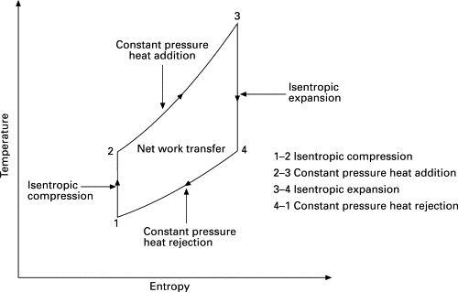
ENTROPY IN IRREVERSIBLE PROCESS:
ENTROPY GENERATION: Entropy generated during process due to irreversibilities in the system. $Q_{Gen}=S_{Gen}$
IRREVERSIBILITIES: The factors which makes a process to be irreversible are called irreversibilities.
TYPES OF IRREVERSIBILITIES
INTERNAL IRREVERSIBILITIES | EXTERNAL IRREVERSIBILITIES
It’s present due to internal factors in the system. E.g. Fluid molecule frictions, Friction between piston and cylinder wall, Etc… | It’s present due to External factors (Surroundings) in the system. E.g. Heat Transfer from External Source (surrounding), Etc…
If it’s zero, Process is Internally Reversible Process. | If it’s zero, Process is Externally Reversible Process.
If both are zero, the process becomes Totally/ Completely Reversible process.
CHANGE OF ENTROPY IN IRREVERSIBLE PROCESS
$$dS=S_{Gen}$$ | $$dS={\left[Q/T\right]}_{IRR}$$
$$dS={\left[\frac{Q}{T}\right]}_{IRR}+S_{Gen}$$ | Where, $dS=$ Change of entropy,  ${\left[Q/T\right]}_{IRR}=$ Entropy transfer due to heat transfer,  $S_{Gen}=$Entropy Generation due to internal irreversibility

$dS$ IN REVERSIBLE PROCESS | $dS$ IN IRREVERSIBLE PROCESS
$$dS={\left[\frac{Q}{T}\right]}_{Rev.}={\left[\frac{Q}{T}\right]}_{Internally Rev.}, Where S_{Gen}=0$$ | $$dS={\left[\frac{Q}{T}\right]}_{IRR}+S_{Gen}$$

REVERSIBLE HEAT TRANSFER | IRREVERSIBLE HEAT TRANSFER
Heat transfer through negligible temperature difference. | Heat transfer through finite temperature difference.
CHANGE OF ENTROPY IN IRREVERSIBLE PROCESS:
$$dS={\left[\frac{Q}{T}\right]}_{IRR}+S_{Gen}$$ | $${\left[Q/T\right]}_{IRR}=+ve,0,-ve$$  $$S_{Gen}=+ve(∵Generated heat is absorbed by sys.)$$
For Irreversible Heat Supply Process, | $${\left[Q/T\right]}_{IRR}=+ve, hence dS=S_{2}-S_{1}>0$$
For Irreversible Heat Rejection Process, | $${\left[Q/T\right]}_{IRR}=-ve, hence dS=S_{2}-S_{1}=+ve,0,-ve$$
For Irreversible Adiabatic Process, | $${\left[Q/T\right]}_{IRR}=0, hence dS=S_{2}-S_{1}>0$$
For Irreversible Adiabatic Expansion Process, | $$Always, dS>0$$
For Irreversible Adiabatic Compression Process, | $$Always, dS>0$$
IMP POINTS W. R. T. ENTROPY IN IRREVERSIBLE PROCESS:
In irreversible process entropy may increase, decrease or may remain constant depending on amount of heat transfer.
Isentropic process need not to be reversible. It can be irreversible process (From above equation,${\left[Q/T\right]}_{IRR}=S_{Gen}$).
Isentropic process need not to be adiabatic. It can be irreversible heat rejection process.

REVERSIBLE ADIABATIC | IRREVERSIBLE ADIABATIC
$$dS=\frac{Q}{T}=\frac{0}{T}=S_{2}-S_{1}=0⇒Isentropic Process$$ | $$dS={\left[\frac{Q}{T}\right]}_{IRR}+S_{Gen}=0+S_{Gen}>0$$
ENTROPY PRINCIPLE:
$$dS={\left[\frac{Q}{T}\right]}_{IRR}+S_{Gen}⇔dS≥{\left[\frac{Q}{T}\right]}_{IRR}$$ | $$dS_{Univ}≥{\left[\frac{Q}{T}\right]}_{IRR}≥0(∵Universe is isolated system, Q=0)$$
$$dS_{Univ}≥0$$ | For Reversible Process, $dS_{Univ}=0$ | For Irreversible Process, $dS_{Univ}>0$
$$dS_{Univ}=dS_{sys}+dS_{surr}$$ | For Impossible Process, $dS_{Univ}<0$
- Entropy of the universe always increases.
FIRST LAW FOR CYCLES: $\oint{Q}=\oint{W}$ | SECOND LAW FOR CYCLES: $\oint{\frac{Q}{T}}≤0$
FIRST LAW FOR PROCESS: $Q=dU+W$ | SECOND LAW FOR PROCESS: $dS_{Univ}≥0$
TdS EQUATIONS:
Change of property (Entropy, etc…) is independent of path in the process. And properties are point function. To find change in entropy use following equations.
$$here, dS_{Rev.}=dS_{Irrev.}=dS$$ | $$Q=dU+W⇒TdS=dU+PdV$$
For ideal gas, | $$dS=\frac{dU}{T}+\frac{P}{T}dV=\frac{mC_{V}dT}{T}+\frac{mR}{V}dV$$ | These equations are valid for reversible and irreversible process.
Substituting Enthalpy formula in the 1st law, | $$TdS=dH-VdP$$
SLOP OF VARIOUS PROCESSES ON THE T-S DIAGRAM:
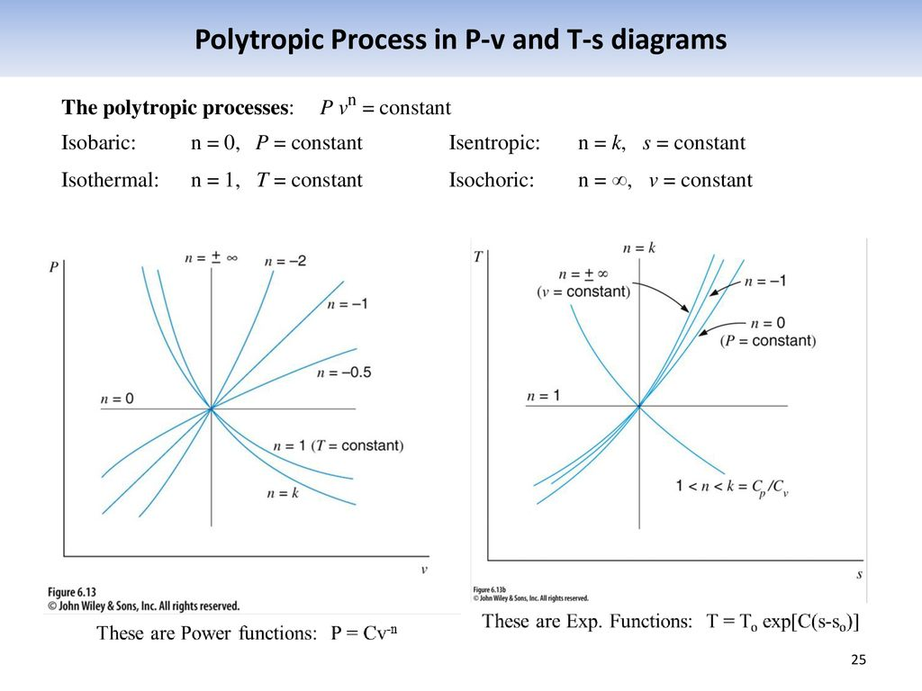
REVERSIBLE ISOCHORIC PROCESS |  | REVERSIBLE ISOBARIC PROCESS
$$TdS=dU+PdV$$  $$Slope={\left[\frac{dT}{dS}\right]}_{V=c}=\frac{T}{C_{V}}$$ | $$PdV=0$$  $$dU=C_{V}dT$$  $$(∵m=1kg)$$ | $$TdS=dH-VdP$$  $$Slope={\left[\frac{dT}{dS}\right]}_{P=c}=\frac{T}{C_{P}}$$ | $$VdP=0$$  $$dH=C_{P}dT$$  $$(∵m=1kg)$$
REVERSIBLE ISOTHERMAL PROCESS |  | REVERSIBLE ADIABATIC PROCESS
$$Slope={\left[\frac{dT}{dS}\right]}_{T=c}=0$$ | $$T=Constant$$  $$dT=0$$ | $$Slope={\left[\frac{dT}{dS}\right]}_{Rev. Adi.}=∞$$ | $$S=Constant$$  $$dS=0$$
REVERSIBLE POLYTROPIC PROCESS |  | OBSERVATION
Like other processes  $$Slope={\left[\frac{dT}{dS}\right]}_{Poly.}=\frac{T}{C_{n}}<0$$ | $$C_{n}=C_{V}\left[\frac{n-γ}{n-1}\right]$$  $$1<n<γ$$ | $${\left[\frac{dT}{dS}\right]}_{V=c}>{\left[\frac{dT}{dS}\right]}_{P=c}(∵C_{P}>C_{V})$$
TS DIAGRAM FOR CARNOT CYCLE: It’s already given in previous chapter.
$\oint{Q}=\oint{W}=W_{net}=Q_{net}=Closed Area on PV diagram=Closed Area on TS diagram=Q_{Supply}-Q_{Reject}$
CHANGE OF ENTROPY FOR IDEAL GASES: Change of entropy in terms of,
$$T \& V$$ | $$T \& P$$ | $$P \& V$$
$$TdS=dU+PdV$$  $$dS= \left({mC_{V}}/T\right)dT+\left({mR}/V\right)dV$$  $$\left(∵dU=mC_{V}dT \& P/T={mR}/V\right)$$  $$∆S= mC_{V}\ln\left(\frac{T_{2}}{T_{1}}\right)+mR\ln\left(\frac{V_{2}}{V_{1}}\right)$$ | $$TdS=dH-VdP$$  $$dS= \left({mC_{P}}/T\right)dT-\left({mR}/P\right)dP$$  $$\left(∵dH=mC_{P}dT \& V/T={mR}/P\right)$$  $$∆S= mC_{P}\ln\left(\frac{T_{2}}{T_{1}}\right)-mR\ln\left(\frac{P_{2}}{P_{1}}\right)$$ | $$∆S= mC_{V}\ln\left(\frac{P_{2}}{P_{1}}\right)+ mC_{P}\ln\left(\frac{V_{2}}{V_{1}}\right)$$  $$∵T\&V or T\&P relation$$  $$\& R=C_{P}-C_{V} \&\frac{PV}{T}=Const.$$
CHANGE OF ENTROPY IN VARIOUS PROCESS: From above 3 equations,
For Reversible Isochoric Process,  $$∆S= mC_{V}\ln\left(\frac{T_{2}}{T_{1}}\right)=mC_{V}\ln\left(\frac{P_{2}}{P_{1}}\right)$$ | For Reversible Isobaric Process,  $$∆S= mC_{P}\ln\left(\frac{T_{2}}{T_{1}}\right)=mC_{P}\ln\left(\frac{V_{2}}{V_{1}}\right)$$ | For Reversible Isothermal Process,  $$∆S=mR\ln\left(\frac{V_{2}}{V_{1}}\right)=-mR\ln\left(\frac{P_{2}}{P_{1}}\right)$$
For Reversible Adiabatic Process, $∆S=0 \left(∵It^{'}s isentropic process\right)$
For Reversible Polytropic Process,
$$∆s= R\ln\left(\frac{T_{2}}{T_{1}}\right)\left[\frac{γ-n}{\left(γ-1\right)}\frac{1}{\left(1-n\right)}\right]=-R\ln\left(\frac{P_{2}}{P_{1}}\right)\left[\frac{γ-n}{n\left(γ-1\right)}\right]=-R\ln\left(\frac{V_{2}}{V_{1}}\right)\left[\frac{γ-n}{γ-1}\right]$$
$$\left(∵T\&V Entropy Relation,C_{V}=R/{\left(γ-1\right)}, Polytropic Process,PV^{n}=Const. \&their relation\right)$$
CHANGE OF ENTROPY FOR SOLIDS & LIQUIDS:
$$TdS=dU+PdV$$  $$∴TdS=mCdT+0\left(∵For solid \& liquid PdV=0\right)$$ | $$∴∆S=mC\ln\left(\frac{T_{2}}{T_{1}}\right)\left(Used for Solid \& liquids\right)$$

CHANGE OF ENTROPY FOR SURROUNDINGS IN ADIABATIC PROCESS: | $$∆S=∆S_{sys}+∆S_{surr}={\left[\frac{Q}{T}\right]}_{sys}+{\left[\frac{Q}{T}\right]}_{surr}={\left[\frac{Q}{T}\right]}_{sys}\left(∵∆S_{surr}={\left[\frac{Q}{T}\right]}_{surr}=0\right)$$

CHANGE OF ENTROPY DUE TO MIXING OF LIQUIDS: It’s mixing of 2 liquids separated by membrane with initial conditions $m_{1}, T_{1} \& m_{2}, T_{2}$.
From the First law TD,  $${\left(Q_{lost}\right)}_{1}={\left(Q_{gained}\right)}_{2}$$ | $$After Mixing, -m_{1}C_{1}\left(T_{1}-T_{f}\right)=m_{2}C_{2}\left(T_{f}-T_{2}\right)⇒T_{f}=\frac{\sum{m_{i}C_{i}T_{i}}}{\sum{m_{i}C_{i}}}$$
Change of Entropy for mixing,  $$∆S_{mix}=∆S_{1}+∆S_{2}$$ | $$Where, ∆S_{1}= m_{1}C_{1}\ln\left(\frac{T_{f}}{T_{1}}\right) \& ∆S_{2}= m_{2}C_{2}\ln\left(\frac{T_{f}}{T_{2}}\right)(∵V_{1}=V_{2})$$
$$∆S_{univ}=∆S_{sys}+∆S_{surr}>0$$ | $$Where, ∆S_{sys}=∆S_{mix} \& ∆S_{surr}=0$$
Given, $m_{1}=m_{2}=m$  $$C_{1}=C_{2}=C$$ | $$∆S_{univ}=∆S_{mix}=∆S_{sys}=2mC\ln\left(\frac{T_{f}}{\sqrt{T_{1}T_{2}}}\right)$$
It’s irreversible process.

CHANGE OF ENTROPY DUE TO MIXING OF IDEAL GASES: It’s mixing of 2 ideal Gases separated by membrane with initial conditions $m_{1}, T_{1} \& m_{2}, T_{2}$.
Change of Entropy for mixing,  $$∆S_{mix}=∆S_{1}+∆S_{2}$$ | $$Where, ∆S_{1}= m_{1}C_{P1}\ln\left(\frac{T_{f}}{T_{1}}\right)-m_{1}R_{1}\ln\left(\frac{P_{f}}{P_{1}}\right)$$  $$\& ∆S_{2}= m_{2}C_{P2}\ln\left(\frac{T_{f}}{T_{2}}\right)-m_{2}R_{2}\ln\left(\frac{P_{f}}{P_{2}}\right)$$
$$∆S_{univ}=∆S_{sys}+∆S_{surr}>0$$ | $$Where, ∆S_{sys}=∆S_{mix} \& ∆S_{surr}=0$$
It’s irreversible process.
CHANGE OF ENTROPY DUE TO MIXING OF DIFFERENT IDEAL GASES: It’s mixing of 2 ideal Gases separated by membrane with initial conditions $n_{1}, T,P \& n_{2}, T,P$ And final Conditions $\left(n_{1}+n_{2}\right), T,P$.
$$∆S_{mix}=∆S_{1}+∆S_{2}$$  Here, $T_{1}=T_{2}=T_{f}$ & $mR=n\overline{R}$ | $$Where, ∆S_{1}=-n_{1}{\overline{R}}_{1}\ln\left(x_{1}\right) \& ∆S_{2}=-n_{2}{\overline{R}}_{2}\ln\left(x_{2}\right)(∵x_{i}=\frac{n_{i}}{n_{mix}}=\frac{P_{i}}{P_{mix}})$$
$$∆S_{univ}=∆S_{sys}+∆S_{surr}>0$$ | $$Where, ∆S_{sys}=∆S_{mix} \& ∆S_{surr}=0$$
It’s irreversible process.
CHANGE OF ENTROPY DUE TO MIXING OF SAME IDEAL GASES: It’s mixing of 2 same ideal Gases separated by membrane with initial conditions $n_{1}, T,P \& n_{2}, T,P$ And final Conditions $\left(n_{1}+n_{2}\right), T,P$.
Here, $x_{1}=x_{2}=1$ | Hence, $∆S_{univ}=∆S_{sys}=∆S_{mix}=∆S_{surr}=0$
CHANGE OF ENTROPY FOR THERMAL RESERVOIRS:
HEAT SOURCE: $∆S_{source}={-Q}/{T_{source}}={-Q}/{T_{1}}$ | HEAT SINK: $∆S_{sink}={+Q}/{T_{sink}}={+Q}/{T_{2}}$
COMBINED HEAT SOURCE & SINK: $∆S_{sys}=∆S_{source}+∆S_{sink}={-Q}/{T_{1}}+Q/{T_{2}}(∵T_{1}>T_{2})$
$$∆S_{univ}={\left[Q/T\right]}_{IRR}+S_{gen}=∆S_{sys}+∆S_{surr} \left(∵∆S_{surr}{\left[Q/T\right]}_{IRR}=0, no heat transfer to surrounding\right)$$
$$T_{1}=T_{2}⇒∆S_{univ}=0(Reversible)$$ | $$T_{1}>T_{2}⇒∆S_{univ}>0(Irreversible)$$ | $$T_{1}<T_{2}⇒∆S_{univ}<0(Impossible)$$

CHANGE OF ENTROPY FOR FINITE BODIES:
FINITE BODY: It has limited volume and size. If infinite body is considered are called reservoirs.
For single Steal Block, | $$∆S_{b}= m_{b}C\ln\left({T_{2}}/{T_{1}}\right)$$
Two Steel Blocks Joined Together, | $$∆S_{sys}=∆S_{1}+∆S_{2}=m_{1}C_{1}\ln\left(\frac{T_{f}}{T_{1}}\right)+m_{2}C_{2}\ln\left(\frac{T_{f}}{T_{2}}\right)\left(here, T_{f}=\frac{\sum{m_{i}C_{i}T_{i}}}{\sum{m_{i}C_{i}}}\right)$$  $$∆S_{univ}=∆S_{sys}+∆S_{surr}, where ∆S_{surr}=0\left(∵no heat transfer to surrounding\right)$$
CHANGE OF ENTROPY FOR CYCLIC DEVICES:
For All cyclic devices, $\oint{dS}=0$ | E.g. Refrigerator, Heat Engine, etc…
A REVERSIBLE HEAT ENGINE BETWEEN IDENTICAL FINITE BODIES:
Work done by engine, $W=Q_{2}-Q_{1}$  $$∴ W=mC(T_{1}+T_{2}-2T_{f})$$  For reversible process, $∆S_{univ}=0$  $$∆S_{univ}=∆S_{HE}+∆S_{surr}=0$$  $$∴∆S_{surr}=∆S_{Hot Reservoir}+∆S_{Cold Reservoir}=0$$  $$∴2mC\ln\left({T_{f}}/{\sqrt{T_{1}T_{2}}}\right)=0$$  $$∴T_{f}=\sqrt{T_{1}T_{2}}$$ | Where, $Q_{1}=-mC\left(T_{f}-T_{1}\right) \& Q_{2}=mC(T_{f}-T_{2})$  $∆S_{HE}=$ 0 (Because of cyclic process),  $$∆S_{Hot Reservoir}=mC\ln\left(\frac{T_{f}}{T_{1}}\right) \&$$  $$∆S_{Cold Reservoir}=mC\ln\left(\frac{T_{f}}{T_{2}}\right)$$  $$∴ W_{max}=mC(T_{1}+T_{2}-2\sqrt{T_{1}T_{2}})$$
A REVERSIBLE REFRIGERATOR BETWEEN IDENTICAL FINITE BODIES:
Work Supply to refrigerator,  $$W=Q_{1}-Q_{2}$$  $$∴ W=mC(T_{2}^{'}+T_{2}-2T_{i})$$  For reversible process, $∆S_{univ}=0$  $$∆S_{univ}=∆S_{HE}+∆S_{surr}=0$$  $$∴∆S_{surr}=∆S_{Body2}+∆S_{Body1}=0$$  $$∴2mC\ln\left({T_{i}}/{\sqrt{T_{2}^{'}T_{2}}}\right)=0$$  $$∴T_{i}=\sqrt{T_{2}^{'}T_{2}}$$ | Where,  $$Q_{1}=mC\left(T_{2}^{'}-T_{i}\right) \& Q_{2}=-mC(T_{2}-T_{i})$$  $∆S_{Ref.}=$ 0 (Because of cyclic process),  $$∆S_{Body2}=m_{1}C_{1}\ln\left(\frac{T_{f}}{T_{1}}\right) \&$$  $$∆S_{Body1}=m_{2}C_{2}\ln\left(\frac{T_{f}}{T_{2}}\right)$$  $$∴ W_{max}=mC({T_{i}^{2}}/{T_{2}}+T_{2}-2\sqrt{T_{i}T_{2}})$$ | Body 2(Q1) $$T_{i}→T_{2}^{'}$$  $$W_{min}→$$ $$REF$$  Body 1(Q2) $$T_{i}→T_{2}$$  Given,  $$m_{1}=m_{2}=m$$  $$C_{1}=C_{2}=C$$
CHANGE OF ENTROPY FOR FINITE BODIES & RESERVOIR:
ELECTRIC COIL AND ATMOSPHERE:
$$∆S_{sys(coil)}=mC\ln\left(\frac{T_{2}}{T_{1}}\right)$$ | $$∆S_{surr(atm)}=\frac{Q}{T_{surr}}$$ | $$Q=VIt=I^{2}Rt$$  $$Q=mCdT$$
COPPER BLOCK PLACING/ DROPPING IN LAKE:
$$∆S_{sys(block)}=mC\ln\left(\frac{T_{2}}{T_{1}}\right)$$ | $$∆S_{surr(lake)}=\frac{Q}{T_{surr}}=\frac{+KE}{T_{surr}}=\frac{+PE}{T_{surr}}$$ | $$Q=mCdT$$
LIQUID WATER AND ATMOSPHERE:
$$∆S_{sys(water)}=mC\ln\left(\frac{T_{2}}{T_{1}}\right)$$ | $$∆S_{surr(atm)}=\frac{-Q}{T_{surr}}$$ | $$Q=mCdT$$
ENTROPY IN OPEN SYSTEM:
CHANGE OF ENTROPY IN OPEN SYSTEM FOR REVERSIBLE PROCESS |  | $$dS={\left[Q/T\right]}_{Rev.}$$
CHANGE OF ENTROPY IN OPEN SYSTEM FOR IRREVERSIBLE PROCESS | $$d\dot{S}={\left[\frac{\dot{Q}}{T}\right]}_{IRR}+{\dot{S}}_{Gen}+\sum{{\left(\dot{m} s\right)}_{in}}-\sum{{\left(\dot{m} s\right)}_{out}}$$
For Steady Flow, $d\dot{S}=0$ | $$\dot{m} ∆s={\left[{\dot{Q}}/T\right]}_{IRR.}+{\dot{S}}_{Gen}$$

Closed and Open System | Closed System and Irr. Process | Open System and Irr. Process (Steady State)
$$dS={\left[Q/T\right]}_{Rev.}$$ | $$dS={\left[Q/T\right]}_{IRR.}+S_{Gen}$$ | $$\dot{m} ∆s={\left[{\dot{Q}}/T\right]}_{IRR.}+{\dot{S}}_{Gen}$$

Reversible Adiabatic Process (Open Sys.) | Irreversible Adiabatic Process (Open Sys.)
$$Isentropic Process$$ | $$\dot{m} ∆s=0+{\dot{S}}_{Gen}>0 Always(∵{\left[{\dot{Q}}/T\right]}_{IRR.}=0)$$

ISENTROPIC EFFICIENCY |  | 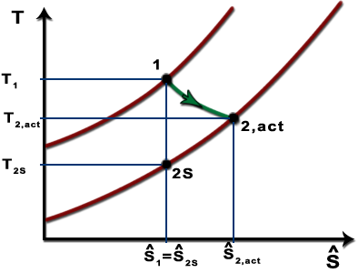 | 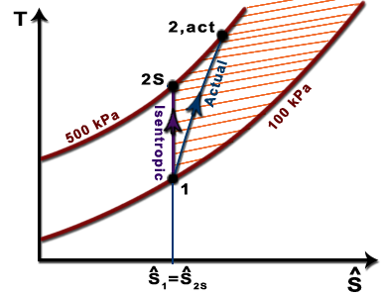
TURBINE | COMPRESSOR
$$η_{ISE-T}=\frac{W_{act}}{W_{ideal}}=\frac{h_{1}-h_{2}^{'}}{h_{1}-h_{2}}$$ | $$η_{ISE-C}=\frac{W_{ideal}}{W_{act}}=\frac{h_{2}-h_{1}}{h_{2}^{'}-h_{1}}$$
$$S_{Gas}>S_{Liquid}>S_{Solid}$$
STATEMENTS OF THIRD LAW OF THERMODYNAMICS:
STATEMENT-I: It’s impossible to produce finite absolute Zero Kelvin temperature in finite number of operations.
STATEMENT-II: Entropy of pure crystalline substance is zero at absolute Zero Kelvin temperature.

